*Return your assignment (via Canvas, by the posted due date) in the form of a Word document (including all answers, figures, and R script).*

*Guidelines for homework document:*

* *include your name at the top of the document*
* *Include the course, lab number, and date at the top of the document*
* *Number and label the questions and answers clearly! (We should easily be able to find your answers!)*
* *Include all of the requested output (e.g., values, data tables, and plots), not just the code for them. (We will not copy your code into R to see if it works).*
* ***Include informative, numbered captions for figures and tables.***
* *Submit a Word (or PDF) document (no .r or .pages files please).*

Include all your code used for the problems.Figure : Plot depicting the abundance (individuals) vs. time (years) for a theoretical fish population starting at 10% of carrying capacity. The pink curve represents a scenario where the intrinsic rate of increase is 0.05 per year,F8766

* ***Answer ALL questions using complete sentences that are clear and informative****.*

**Logistic growth**

The logistic growth model is very common in ecology and fisheries. It is derived from the differential equation:

$$\frac{dN}{dt}=rN(1-\frac{N}{K})$$

where dN/dt is the rate of population change over time (also known as the ***production***), N is abundance, r is the intrinsic rate of increase (per unit time), and K is the carrying capacity. The analytical solution is the **continuous-time version of the logistic model**, which is written as:

$$N_{t}=\frac{K}{1+(\frac{K-N_{0}}{N_{0}})e^{-rt}}$$

where Nt is the number at time t, N0 is the initial population size, and the other parameters maintain their same meaning. The **discrete time version of the logistic growth model** (more common in fisheries) is:

$$N_{t+1}=N_{t}+rN_{t}(1-\frac{N_{t}}{K})$$

1. Assume that a population is at an equilibrium, or carrying capacity, of 100,000 individuals before intensive fishing cropped the population down to 10% of carrying capacity (i.e., there was a 90% decline in the population). Suppose the fishing was stopped and the population is expected to grow logistically with an intrinsic rate of increase of either r=0.05 yr-1 or r=0.2 yr-1. Use the *continuous* version of the equation for all the questions below. (10 pts)
   1. Create a plot that depicts the abundance of the population for 140 years after fishing was stopped, under both of the r scenarios (r=0.05 and r=0.2). (2 pts)
   2. What would the population size be after 10 years of recovery for each of the two scenarios? (2 pts)
   3. What percentage of the carrying capacity do those values equate to? (2 pts)
   4. For each of the two r scenarios (r=0.05 and r=0.2), how many years would it take for the population to reach 75% of K? (2 pts)
   5. What is the maximum population growth rate (i.e., dN/dt) for each of the two scenarios? (2 pts)
2. A discrete-time version of the logistic model is often used in fisheries applications, as we will see more later in the semester. In lecture, we said that the dynamics of a system can become very unusual when using a discrete-time version of the model if r is increased to very high (typically unrealistic) values. This can lead to damped oscillations, cyclical dynamics, stable limit cycles, or chaos. Modify the code from lab and play around with the parameter values to generate some of these patterns. (3 pts)
   1. Generate at least 2 plots that reflect some of these unusual dynamics and include them here. (2 pts)
   2. State why you think those patterns develop instead of the nice smooth curves we get with the continuous-time version of the model. (1 pts)
3. The exponential and logistic growth models are important within fisheries science and ecology more generally. The graphs below depict some of the underlying relationships of the two models, as provided in the summary slide from “Lecture 04 - Logistic Growth Model”. Use this and the lectures as a reference for answering the questions below. (11 pts)

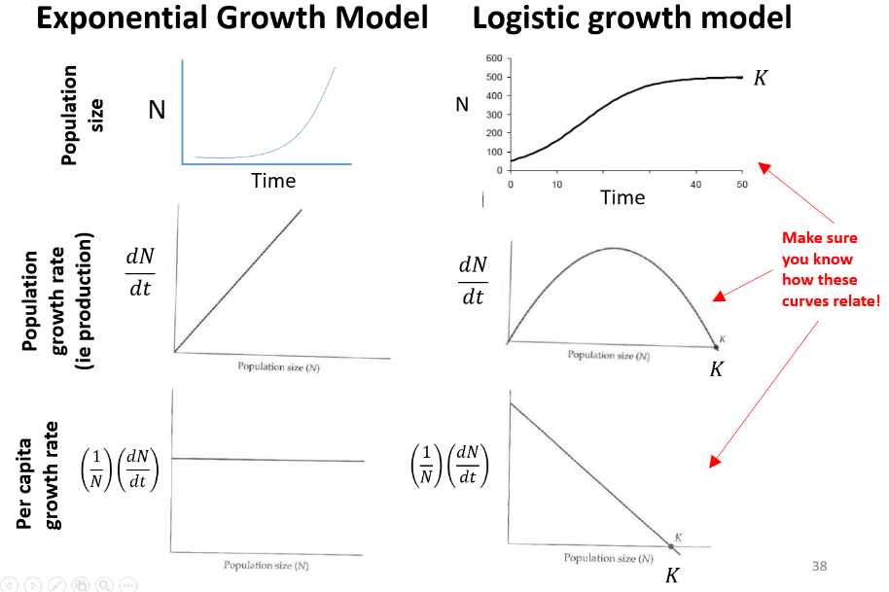

* 1. Use R to generate a set of plots that depict **A)** Population Size vs. time, **B)** Population Growth Rate (aka, Production or dN/dt) vs Abundance, and **C)** Per Capita Growth Rate vs. Abundance, for both the exponential model and the logistic model. Instead of making 6 separate plots (as shown above), you should have 3 plots, because you will be putting the exponential and logistic models together. Use a different line color or line type to represent the exponential and logistic growth models, so they can be on the same plot. To generate the data to make the plots, assume the following parameter values: N0 = 2 fish, r=0.1 yr-1, and K = 100 fish, with time (t) going from 0 to 100 years. Please include a figure caption with your figure. (4 pts)
  2. For each of the three plots, explain how the exponential and logistic models compare and why. (3 pts)
  3. Explain how the population size plot (A) relates to the population growth rate plot (B). Also, where is the population growth rate the largest and why? (2 pts)
  4. Explain how the population growth rate plot (B) related to the per capita growth rate (C) (using equations may be helpful in your explanation). (2 pts)

1. Answer the following
   1. How many hours did you spend on completing this entire homework?
   2. Work in a group for at least part of the homework (or to confirm answers) and include a screen shot of you doing it (e.g., meeting in person or on zoom, Facetiming, exchanging emails, etc). (+1 extra credit)

**Extra questions for 558 students (9 pts; up to 3 points extra credit for 458):**

1. In Chapter 1 of the Gotelli reading (section called “Environmental Stochasticity”) and in a lecture slide, it was discussed how to add environmental stochasticity into the exponential growth model to yield the figure below. Using the following parameters (N0=20, r=0.05, $σ_{r}$ =0.01),**generate a similar stochastic population model using the *continuous* form of the logistic growth model**. Run the simulation for 120 years, with a constant K value of 1000. To do this, you will need to create a vector of 120 r values that is randomly picked using the rnorm() function (with the specified mean of $\overline{r}=0.05$ and standard deviation of $σ_{r}$ =0.01). Then, calculate what the 120 N values would be using those randomly selected r values.
   1. Create a plot of your model simulation with $\overline{r}=0.05$. (3 pts)
   2. Rerun your simulation and create a similar plot, but now use a mean of $\overline{r}=0.2$. (3 pts)
   3. Describe the differences between parts *a* and *b*, and what the reason(s) are for those differences. (3 pts)

